<https://www.lsm.lv/raksts/zinas/arzemes/02.10.2024-japanas-drosibas-politikas-petnieks-krievijas-draudi-nekur-nav-zudusi.a570921/>

**Japan security policy researcher: the Russian threat hasn’t disappeared anywhere**

02.10.2024, 8:40

**Author:** [Rihards Millers](https://www.lsm.lv/autors/rihards-millers/) *(Latvian Radio foreign news journalist)*

**While Japan, like a number of other countries in the Asia-Pacific region, sees the policies of China and North Korea as a greater threat, the potential Russian threat has not gone away. Especially given Moscow's intensifying relations with Beijing and Pyongyang at a time when the Kremlin is seeking support for aggression against Ukraine.**

This is the conclusion of Akio Takahara, Distinguished Visiting Professor of Asian Security Policy at Tokyo Woman's Christian University, in an interview with Latvian Radio. He recently visited Riga, where he gave a lecture on the changing security situation in the Asia-Oceania region.

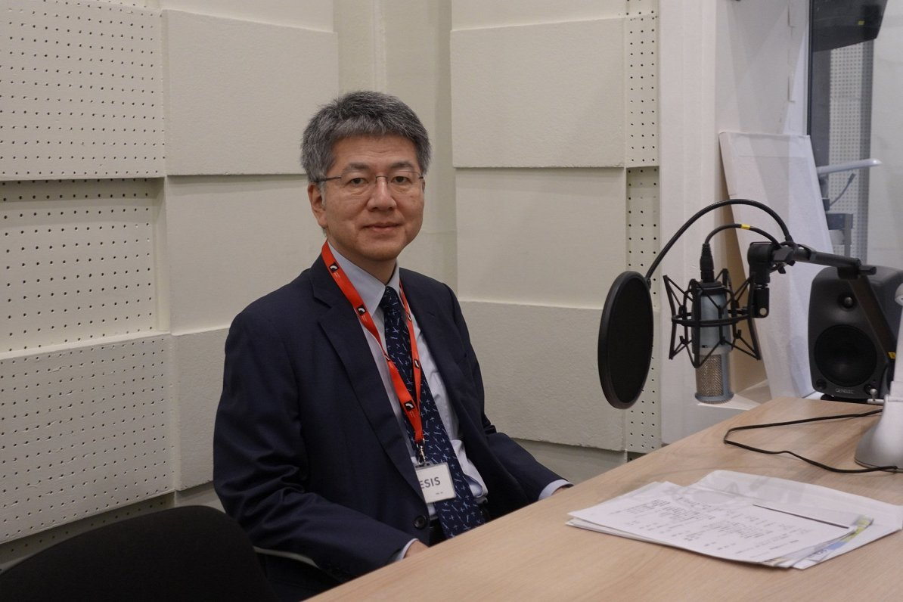

Akio Takahara, researcher of Japan’s security policy

Photo by Rihards Millers, Latvian Radio

The researcher was invited to talk by Latvian Radio journalist Rihards Millers.

**Rihards Millers: We have recently seen evidence of growing relations between Russia and North Korea: messages underlining good bilateral relations, including during the recent visit of a delegation led by former Russian Defence Minister Sergei Shoigu. And, of course, evidence of use of North Korea's weapons in Russia's war against Ukraine. What do North Korea and Russia want to achieve? Does the two countries have anything more than calculation-based needs?**

**Akio Takahara:** It is now quite clear that both sides need each other. I think for Russia, of course, the munitions are important. All the military support coming from Pyongyang is very useful for them. From the North Korean point of view, the provision of military technology, space and other technologies, I think, is something that they really want. This kind of complementary relationship is also being built and developed at the moment.

**Staying on the subject of Russia, I would like to ask about relations between Russia and China. Taking Russia's war in Ukraine as an example, we can see that relations between Moscow and Beijing have remained strong against the backdrop of Western sanctions against Russia. What are the motives behind the relationship between China and Russia?**

For China, the most important thing in foreign policy is winning the strategic competition with the US. They understand quite well that to win this competition they need Russia to exist. They understand that there are many contradictions between Beijing and Moscow, but despite these contradictions, they know that they need each other. This is the main reason why China is supporting Putin in the Ukraine war.

**Will relationships between China and Russia deepen in the future?**

I think it's obvious that [Chinese leader] Xi Jinping doesn't like Putin's war in Ukraine. But as long as it continues, China will inevitably continue to support Putin. In that sense, relationships will deepen. From Russia's point of view, China is a reliable partner. Even after the outbreak of war, the two leaders have met many times, each time announcing an intensification of cooperation. In that sense, as long as the war continues, Russia will need China even more. And relationships will continue to deepen for some time.

**How should Europe respond to the deepening of the relationship between China and Russia?**

European leaders have repeatedly called on Xi Jinping not to supply [Russia] with military technology, dual-use technology and dual-use goods. But I do not think that has worked so far. But I am sure that European leaders will try to tell them [the Chinese] that this is unacceptable in Europe.

I am not sure how well Xi Jinping understands that the Europeans really want China to stop sending these dual-use goods to Russia. You know, I heard a rumour: when German Chancellor Olaf Scholz visited Beijing in April and raised this issue, Xi Jinping said, as if to mock, 'Well, if we export ice cream to Russia and if a Russian soldier eats that ice cream, is that a dual-use goods?' But that is not an attitude that Europeans accept. The Europeans will try [to explain], but I am not sure how much the Chinese side will listen.

**In recent years, China has been increasingly assertive in its claims in East Asia, including on the Taiwan issue, as well as in the South China Sea. The recent disputes with the Philippines are just a few examples. Why is China so interested in the region? What does Beijing want to achieve?**

Xi Jinping has made it clear to his inner audience: a real world power is one that has land power and sea power. That is why we need to go out to the ocean. These are the words of Xi Jinping. China's dream is to become a real world power and, in order to achieve this, it is important for him that China becomes a sea power and goes out to the Pacific. But Xi Jinping also understands that geopolitically, or at least geographically, China is half bounded - these are his words - by the first chain of islands. It is a chain of islands linking the Japanese archipelago, Taiwan, the Philippines, Indonesia. He wants to develop his naval capability so that he can go beyond this first island chain.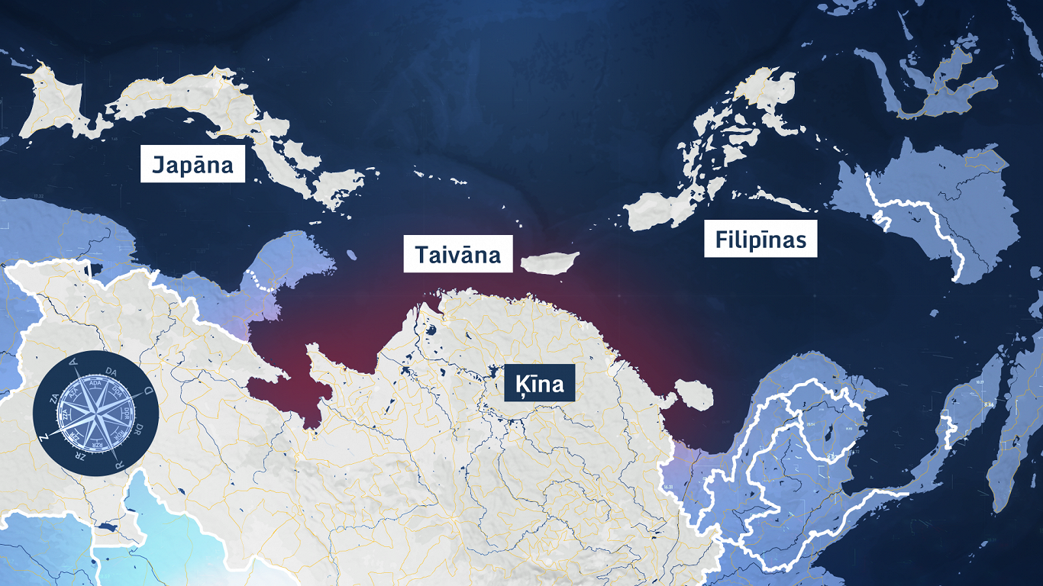

A chain of islands linking the Japanese archipelago, Taiwan and the Philippines, and partially restricting China's movement into the seas

Photo: Latvian Television

From that point of view, unification with Taiwan would have a new meaning. That unification with Taiwan would not only achieve this nationalist dream of uniting the Chinese people, but would also create a beachhead, a breaking point in the Pacific. For all these reasons, Xi is trying very hard to get a good grip on this island chain and even beyond.

**Why does China need it? It is already a powerful country. Why do they need this influence in the Indo-Pacific region?**

I think we should all address this question to Xi Jinping. But now China is modernizing. When a country is in the process of modernization - we have this experience in Japan - we are obsessed with the paradigm of enriching the country and strengthening the army. China is now at that stage. Nationalist sentiment is very high in China, including among ordinary people.

In this situation, and also because of the competition with the US, people are now obsessed with this idea that they have to develop, be more influential, be on a par with the US and, at the end of the day, take the position that the US is in at the moment. But first they want to be like the US - powerful, rich, respected by other countries. So they want to expand [their influence].

**What is Japan's view on the current security challenges in East Asia and the Indo-Pacific region?**

Previously, we were not very concerned about China's growth. In fact, we have been very supportive of China's economic growth. To this day, we remain China's largest donor country. I say this to many friends who come to visit me in Japan from abroad. One Ethiopian journalist could not believe it. He did not know that Japan was a major contributor to China's growth. In any case, it is true.

We have no objections about economic growth; we are still benefiting from China's economic growth today. However, China's military growth is a major problem. Not only for Japan, but also for China's neighbours, for the reasons that I have tried to explain to you. That they are now acting in a confident and even aggressive manner. They are not only increasing their military capabilities, they are even acting - using those military capabilities to put a lot of pressure on us to make concessions.

[Sun Tzu](https://en.wikipedia.org/wiki/Sun_Tzu) “The Art of War” tells us that the best way to win a war is not to fight it. To win without fighting. They think this can be achieved by building up capabilities, by "salami tactics". Gradually, they will get closer to us, and that is a lot of pressure that we are feeling. Because China is so big compared to its neighbours. So this is a situation that not only Japan is facing at the moment, but also all of China's neighbours.

**Could you explain what "salami tactics" mean?**

By increasing their comprehensive national power as far as sea power is concerned - their naval and coastguard capabilities - they will start doing things they did not do before. For example, in the case of Japan, in December 1971, they suddenly laid claim about our islands in Okinawa. They had never made such claims before. But first they did nothing about it. We had a tacit agreement that neither side would mention this issue.

As soon as they started to increase their capacity, they started to act. They now frequently send their coastguard vessels into the territorial waters around the Senkaku Islands (as these disputed islands are called). We need to increase our coastguard capabilities and prevent them from entering. As soon as they arrive, we need to push them back. That is one example I can give. Whenever they send their coastguard ships, there are navy ships behind them.

In the case of Taiwan, before the build-up of capabilities, they were shy of flying over the so-called 'median line' between Taiwan and mainland China. Now that their capabilities have increased, they will simply fly over it very carelessly. And we know what is happening now in the South China Sea. They have become much more aggressive, there is much more friction or even confrontation with countries like the Philippines. These are examples of 'salami tactics'. *("Salami tactics" - a strategy in which an opponent takes incremental, small steps, seemingly innocuous actions, to achieve a larger goal - ed.)* Before, they couldn't do it, but gradually they are extending their reach.

**The China-Africa Forum was recently held in Beijing. What are some of the conclusions of this forum, and what could be the implications for deepening China's relations with African countries?**

This time, some 50 African heads of state were invited to Beijing. It's called FOCAC, or Forum on China-Africa Cooperation, and it takes place every three years. This is actually a replica of TICAD, the Tokyo International Conference on African Development, which we started earlier. We used to hold it every five years, but now FOCAC is held every three years. We have also shortened the cycle. It is a very good opportunity for China to show the world how important relations with Africa are. They are very much focused on Africa's development.

However, this time, compared with last year, when the Belt and Road Forum for International Cooperation was held, it has become clear that China can’t implement so many large infrastructure projects. But they will put more emphasis on smaller-scale projects, which they say are closer to people's livelihoods. This is good for Africans and also for the Chinese.

But I think one reason why they have changed their emphasis is that they can no longer afford to finance all these big projects. And, as you know, infrastructure projects are not profitable. It is very difficult for them to be economically viable. I am sure that many Chinese banks are finding it difficult to finance these big projects, so they want to focus on smaller ones.

This time, Xi Jinping had various projects to offer to African countries. Among them are some large, symbolic infrastructure projects. But there were also many smaller, closer to people's livelihood type projects. Also military aid, military assistance, including the training of African officers. African leaders were offered a very rich choice of projects this time. I am sure that this made the African leaders very happy.

**I wanted to ask about Japan's support for Ukraine. Your country has strongly supported Ukraine over the past two years, pledging billions of dollars in aid, among other things. What motivates Japan to support Ukraine?**

You know, we were so angry with Putin when he invaded Ukraine because our people have deep memories of the Second World War and the grave mistake we made. The lesson that we learnt - not only the Japanese, but also humanity - from two terrible world wars in the 20th century was that you should not impose your will on other countries by force.

When Russia, a permanent member of the UN Security Council, loudly violated the UN Charter and invaded its neighbour, we were very shocked and we were very angry. We feel that we cannot allow Putin to succeed in this outrageous endeavour. That is the main reason.

We are very supportive of Ukraine. With more than a billion euros, if not more - I am sorry, I do not have the exact figures in my head. But we have constitutional restrictions, so we can’t export lethal weapons. However, we are supplying Ukraine with a lot of humanitarian aid, other non-lethal military supplies - like helmets and things like that.

**It has been suggested that the Ukraine scenario could be repeated in East Asia, with possible Chinese action against Taiwan. Do you think that China could pursue a similar scenario with regard to Taiwan, or are these two different cases?**

We can’t rule out the possibility that something similar could happen with Taiwan. That is why we can’t let our guard down. My hunch - my analysis, like the other China and Taiwan experts in Japan - is that we can’t rule it out. However, it is unlikely that a Chinese invasion of Taiwan is imminent. Why? Simply put, Xi Jinping's top priority is not unification with Taiwan, but preserving his regime and power. If one day he comes to the judgement that an invasion of Taiwan helps to prop up his power and his regime, perhaps he will take the decision to invade. But it will not be today or tomorrow, because he understands the risks involved.

As I said, nationalist sentiment is high in China, but at the same time I think that the realism that those in power in China hold on to is still in place. Relatively speaking, they will take more realistic decisions about the risks. They are unlikely to make any adventures in the near future.

**How much of a security threat is Russia in the Indo-Pacific region or East Asia today?**

Russia itself is not seen as a major threat at the moment. China's actions and North Korea's missile [program] and development of nuclear capabilities are. But, as we said, Russia's relationships with these two countries are very close. If one day something happens, Russia will be there with these two countries. In that sense, the potential Russian threat has not disappeared anywhere.